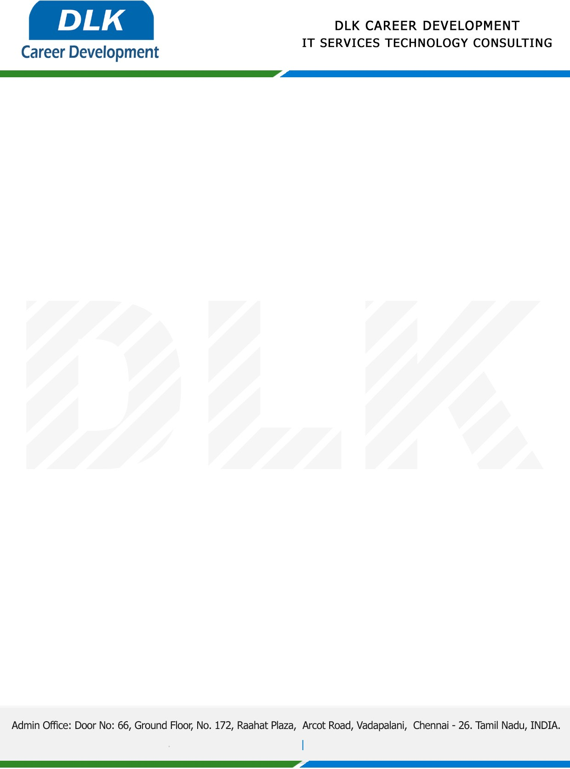

Date: 02 / December/ 2022

**To**

Department of MCA ([Computer Application),](https://www.cseindia.org/)

Head of Department,

Dr.MGR Educational & Research Institute, Chennai - 600095.

**Sub: Letter of Project Acceptance**

This is to certify that **MS DIVYA R(REG NO: 214012101052)** final year student of has accepted the Project Work duration from **10th December 2022 to 05th March 2023** under the domain **“JAVA”.** During the project, all information and data collected from you should be kept confidential.

**Topic:** An Effective Blockchain-Based Traceability System for Farming Fruits and Vegetables Using ABE Algorithm.

We appreciate your interest in **DLK CAREER DEVELOPMENT**

